Module 4 Project: A Prescriptive Model for Strategic Decision-making, An Inventory Management Decision Model

Dhairyav Jatin Shah

College of Professional Studies, Northeastern University

Professor: Zhi(Richard) He

March 22, 2023

**Introduction**

An essential component of operating any business is inventory management. The financial health of a firm can be significantly impacted by decisions made regarding inventories. When it comes to inventory, managers often have to choose between two options: how much to order or manufacture and when to do it. Many elements, including storage costs, handling costs, purchase costs, transportation costs, and opportunity costs are considered while making these selections.

A consulting firm has been approached by a manufacturing company that is struggling with inventory management for a key engine component. The goal is to develop and implement a decision model that will help the company make the best decision possible. To do this, we will be using both Excel and R to create mathematical functions that will help us calculate the annual holding and ordering costs, determine an approximate order quantity that results in the lowest total cost, and conduct what-if analyses to study how changes in model parameters could affect the total cost.

Additionally, we will be simulating the problem in R to estimate the expected minimum total cost, order quantity, and annual number of orders. This will involve constructing a 95% confidence interval and identifying the probability distribution that best fits the data. By using a combination of analytical tools and data-driven insights, we will help the manufacturing company optimize its inventory management processes and improve its financial performance.

**Part 1**

We can define the given problem in the following way:

* 1. Uncontrollable Outputs:
     1. Annual demand: 16,500
  2. Model Parameters:
     1. Cost Per Unit : $79
     2. Opportunity Cost : 12.5% of the unit value
     3. Cost per order : $200.
     4. Holding Cost : $9.88
  3. Decision Parameters :
     1. Order quantity

The inventory management model considers the annual demand as an input that cannot be controlled by the decision-maker and is therefore we consider it as an uncontrolled variable. In contrast, the cost per unit, holding cost per unit, and cost per order are parameters that are under the control of the decision-maker and are used to assess and compare various options in the model, hence we have considered it as our model parameters. The decision parameter in this model is the quantity of the order as it will influence the total inventory cost.

The EOQ (Economic Order Quantity) is a tool used in inventory management to calculate the most cost-effective order quantity that minimizes total inventory expenses. Therefore, we would use the formula for the same to calculate the reorder point in our model.

$$Reorder point= √\frac{2*Annual Demand*Order Cost}{Holding Cost}$$

To minimize the total inventory cost, we can use the formula to calculate the optimal order quantity. Once we have obtained this value, we can then calculate the total inventory cost.

Using the EOQ formula, it was determined that the most efficient order quantity for the given data is **818** units. However, due to company policy, the order quantity must be 1.9 times the unit at the reorder point. Therefore, we will need to order **1553** units per order, which is 1.9 times the EOQ value. With an annual demand of **16,500** units, it can be expected that approximately **11** orders will be placed in a year, with each order containing **1553** units.

Next, we calculate the total inventory cost for the company, we will calculate it using the following formula,

$$Total Inventory Cost=Annual Ordering Cost+Annual Holding Cost$$

The formula for Annual Ordering and Holding Cost is given by,

$$Annual Holding Cost= \frac{Annual Demand}{Reorder point of the company}*Ordering cost$$

$$Annual Holding Cost= \frac{16500}{1553}*200$$

$$Annual Ordering Cost= \frac{Reording Point}{2}*Holding Cost$$

$$Annual Ordering Cost= \frac{818}{2}*9.88$$

Upon calculating the values in excel, we obtain the following output,



From the above table we can see that the company would be spending a minimum of $6,161.05 for the order quantity of 1553 and a total number of 11 orders annually. The same results have been computed in R as well, the code file for R has been attached along with the report.

To calculate an approximate order quantity for the smallest cost, we use the Data tables in excel. The following table displays the obtained results.



According to the data table, we discovered that the smallest amount available for purchase was **$5,858.42**, which translates to an order quantity of **1153**.

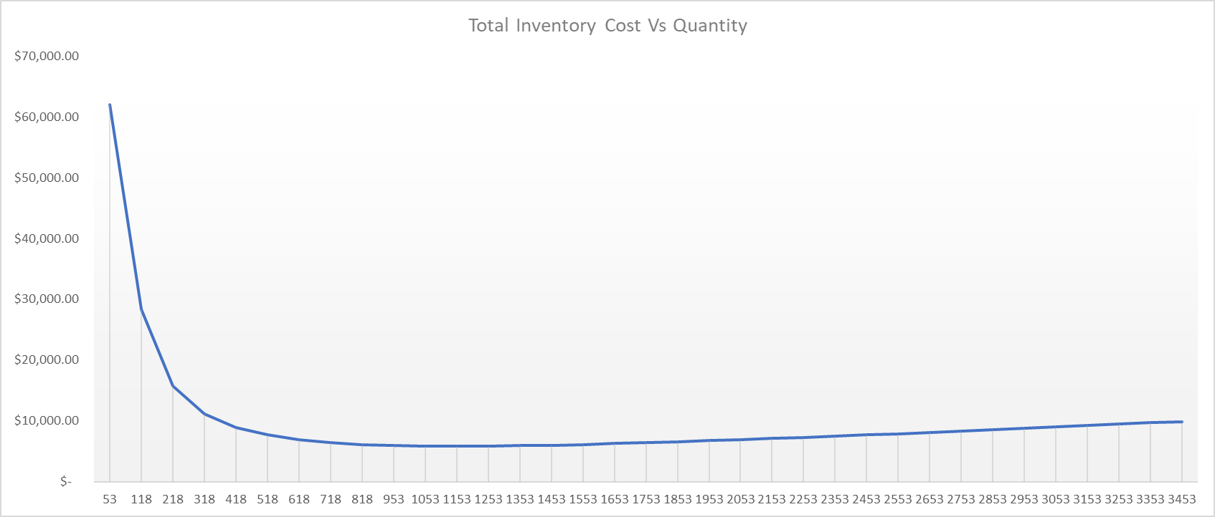The chart illustrates that the Annual total cost experiences a decline initially as the order point rises. Eventually, it reaches a point where the total cost is at its lowest. Any order quantity exceeding this minimum point leads to an increase in the total cost. The order quantity that corresponds to the minimum cost is **1153**, with a value of **$5,858.42**.

The validity of the data table results was tested using Excel Solver. The objective was to achieve the lowest possible total cost by altering the variable reorder point. The Solver produced the following results.



The overall cost of inventory management in this case dropped from **$6,161.05** to **$5,856.84** after Excel Solver was used. Setting a new reorder point of **593** and a reorder quantity of **1,127** allowed for this cost reduction, which reduced both the annual holding and ordering expenses. The quantity of orders also increased to **15**. The sensitivity report for the excel solver is given below,

Next, we conduct what-if analysis to create a 2-way table to study the sensitivity of the total cost when the parameters are changed. For this we have selected total holding cost and order cost as the 2 parameters. The holding cost has been increased and decreased by 2.5% and the order cost has been increased and decreased by $25. The following table shows the output of the what-if analysis conducted.

**Part 2**

We conducted tests to examine the effects of various annual demands on the ideal values for minimal total cost, order amount, and number of orders using the model parameters indicated above. A triangular distribution was created for the annual demand with the minimum demand set at 12,000 units, the maximum demand at 21,000 units, and the mode at 19,000 units. By producing numbers for annual demand, we used simulation to determine the best values for these parameters.

**Estimating the minimum total cost**

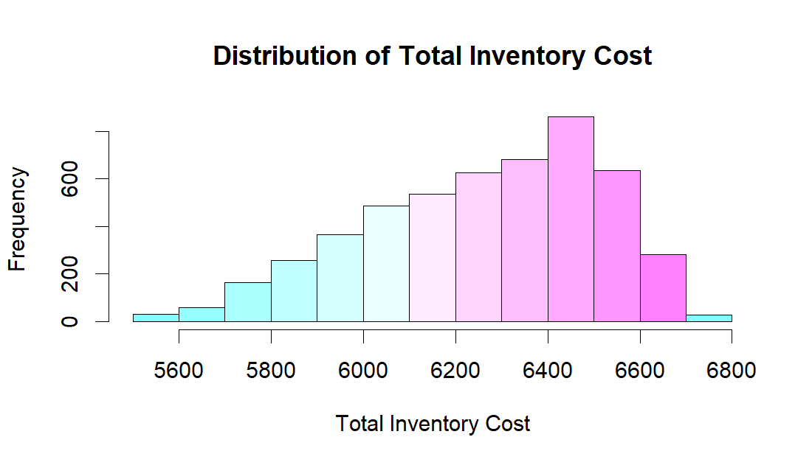Upon performing the simulation, we find that, the estimate minimum total cost fall in the range between (6255.47,6269.5) with a confidence interval of 95%. We assume that the minimum total cost follows a normal distribution. The histogram for the same is given below.

* *Null Hypothesis: total cost follows normal distribution.*
* *Alternative Hypothesis: total cost does not follow normal distribution.*

From the Chi-squared goodness of fit test we can see that the p-value is greater than our alpha. Hence, we fail to reject our null hypothesis and can conclude that total cost follows a normal distribution.

**Estimating the expected order quantity**

Upon performing the simulation, we find that the estimated expected order quantity fall in the range between (833.64,836.32) with a confidence interval of 95%. We assume that the minimum total cost follows a normal distribution. The histogram for the same is given below.

* *Null Hypothesis: expected order quantity follows normal distribution.*
* 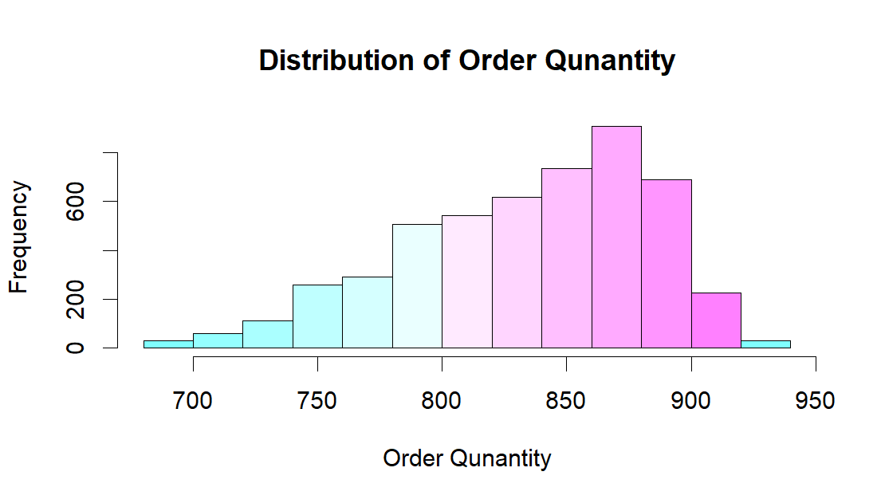*Alternative Hypothesis: expected order quantity does not follow normal distribution.*

From the Chi-squared goodness of fit test we can see that the p-value is greater than our alpha. Hence, we fail to reject our null hypothesis and can conclude that order quantity follows a normal distribution.

**Estimating the expected annual number of orders**

Upon performing the simulation, we find that the estimated expected annual number of orders fall in the range between (11.1,11.17) with a confidence interval of 95%. We assume that the minimum total cost follows a normal distribution. The histogram for the same is given below.

* *Null Hypothesis: number of orders follows normal distribution.*
* *Alternative Hypothesis: number of orders does not follow normal distribution.*

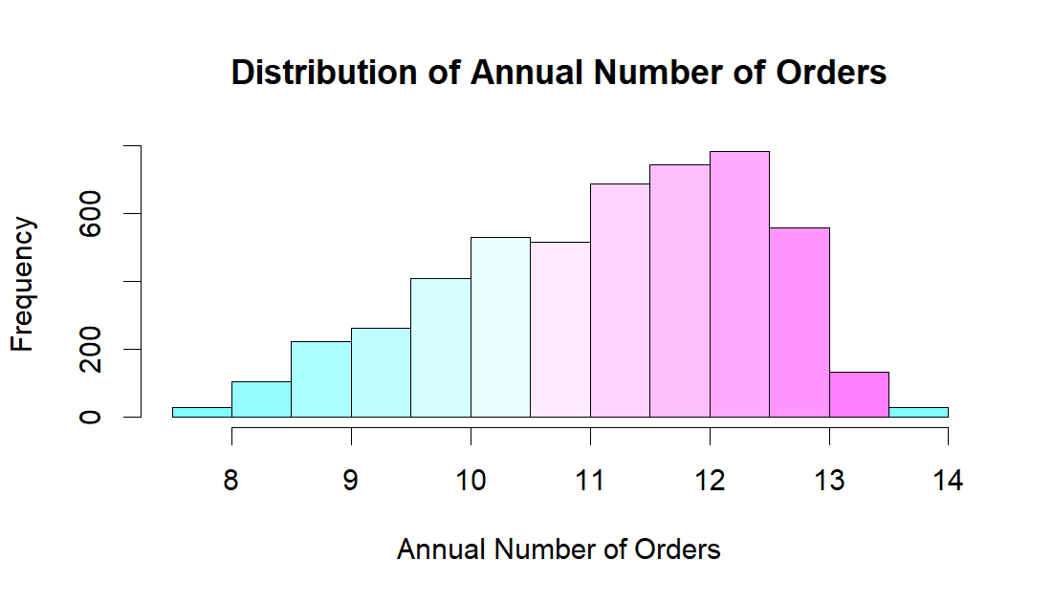

From the Chi-squared goodness of fit test we can see that the p-value is greater than our alpha. Hence, we fail to reject our null hypothesis and can conclude that the annual number of orders follows a normal distribution.

**Conclusion**

We analyzed the data using three different methods: Reorder point mathematical model, Excel data table, and Solver. The reorder point mathematical model gave us an optimal reordering point of **818**, with a total cost of around **$6161.05** when **11** orders were placed. However, the Excel data table and Solver produced a more favorable outcome with a minimum total cost of approximately **$5856.64** and an order quantity of around **593**. We also observed that an increase in the cost per unit and per order would result in a higher total cost. Therefore, we recommend maintaining the reorder point at **593** and ordering about **1127** units per order to minimize the total cost.

**Reference**

1. *Lesson 4-2 — Prescriptive Models* <https://northeastern.instructure.com/courses/131431/pages/lesson-4-2-prescriptive-models?module_item_id=8233736>
2. *Module 4 Lab 1 A Minimizing Decision Model* <https://northeastern.instructure.com/courses/131431/pages/module-4-lab-1-a-minimizing-decision-model?module_item_id=8233742>
3. Gharani.L. (2022, 21st December). *Excel What-If Analysis Data Table | Easy to Use Once you Learn This* <https://www.youtube.com/watch?v=4VuO1lO6USo>